2025/2026 Annual Community Consultation Report Authorisation 355 (A355)

Annual Community Consultation Report Details

Authority Number: | Authorisation 355 (A355)
Original Grant Date: | 19 July 1984
Expiry Date: | 19 July 2028
Reporting Period: | 20 July 2025 – 19 July 2026
Project and Location: | Boggabri Coal Project, Boggabri, NSW
Project Operator: | Boggabri Coal Pty Limited
Report Date: | August 2026
Report Author: | Allan Hogeveen

Technical Manager Details

Technical Manager: | Shane Wright  Chief Operating Officer
Phone: | 07 3222 5689
Mobile: | 0417 072 804
Email: | Shane.Wright@idemitsu.com.au

Document details and history

Document details
Document title | 2025/2026 Annual Community Consultation Report Authorisation 355 (A355)
File name | 2024 Annual community consultation report Authorisation 355 (A355)_Final

Document status and review
Edition | Comments | Author | Authorised by | Date
V1 | First draft | Allan Hogeveen  Head of Technical Services | Allan Hogeveen | 27/07/2025
V2 | Review | Alex Williams  Environment and Biodiversity Manager | Allan Hogeveen
Final | Report approval | Shane Wright  Chief Operating Officer | Allan Hogeveen

Table of contents
Document details and history 3
Executive Summary 7
1.0 Introduction 8
1.1 Approach to community consultation 8
2.0 Community consultation undertaken in reporting period 11
2.1 Details of consultation 11
2.2 Dates and times 12
2.3 Objectives of community consultation events 12
2.4 Issues and topics raised in discussion 13
3.0 Government agency consultation undertaken in reporting period 14
3.1 Details of consultation 14
4.0 How feedback was collected 15
5.0 Responses to any issues raised 16
6.0 Summary and nature of complaints received 17
7.0 Activity alterations in response to issues raised 18
8.0 Outcomes of the consultation 19
9.0 Assessment of how well objectives were met 20
10.0 Summary of Amendments to the Communication Consultation Strategy or Activity 21
11.0 Commitments for Ongoing consultation 22

List of figures and tables
Figure 1-1: Boggabri Regional Location 9
Figure 1-2: Location and access for Boggabri coal tenures 10
Table 1: Dates and Times of Stakeholder and Consultation Activities 11
Table 2: Topics and issues raised in discussion 13

Executive Summary
This is an “Annual community consultation report” in accordance with the Exploration Code of Practice: community consultation (March 2016) and adheres to section 4.1 of the Guideline for community consultation requirements for exploration (1 March 2016).
The Community Consultative Committee (CCC) meetings were the principal forum for communicating exploration activities on A355 during the period with meetings held in September and October 2025 and in February and May 2026.
No drilling activity was conducted during this reporting period (20 July 2025 – 19 July 2026).
The consultation activities that were undertaken by BCM during this reporting period included:
- meetings with local government and key stakeholders;
- responding to correspondence;
- maintaining the Boggabri Project webpage; and
- management of the dedicated project email address and phone number.
No issues have been raised with BCM in relation to A355 exploration during the reporting period.
The overall outcome of consultation conducted during this reporting period was a greater understanding of the project, and the mining and planning process. This contributed to fostering a positive and transparent relationship between BCM Project stakeholders.

Introduction
A355 is in the Gunnedah Coalfield of NSW, approximately 370 km northwest of the Port of Newcastle, and about 16 km by road northeast of the Boggabri township. Current access to the site is via forestry tracks within the project boundary.
It sits adjacent to the currently operating BCM and is a part of the BCM Project.
Figure 1-1 and Figure 1-2 show the regional location and tenement plans for A355.

Approach to community consultation
Idemitsu Australia (IA) and BCM have developed an approach to community consultation for the BCM Project complied with the Code of Practice and is described in the Environmental Management Strategy.
The approach supports IA’s ongoing social license to operate by adopting a shared value approach to ensure benefits are experienced by IA and the community that address local community issues.

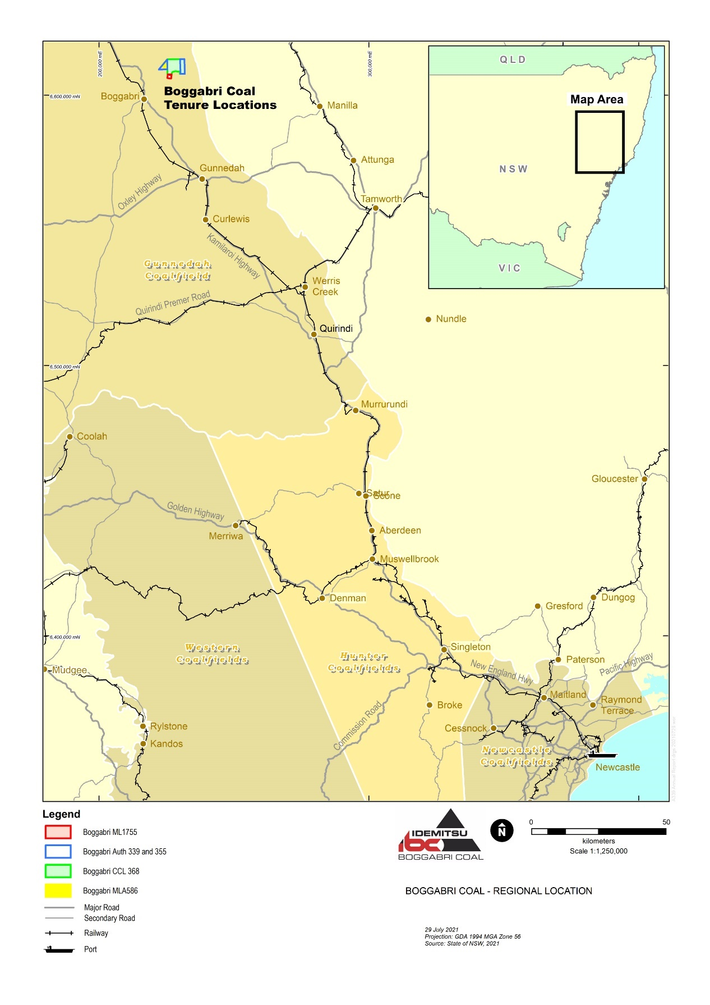

Figure 1-1: Boggabri Regional Location

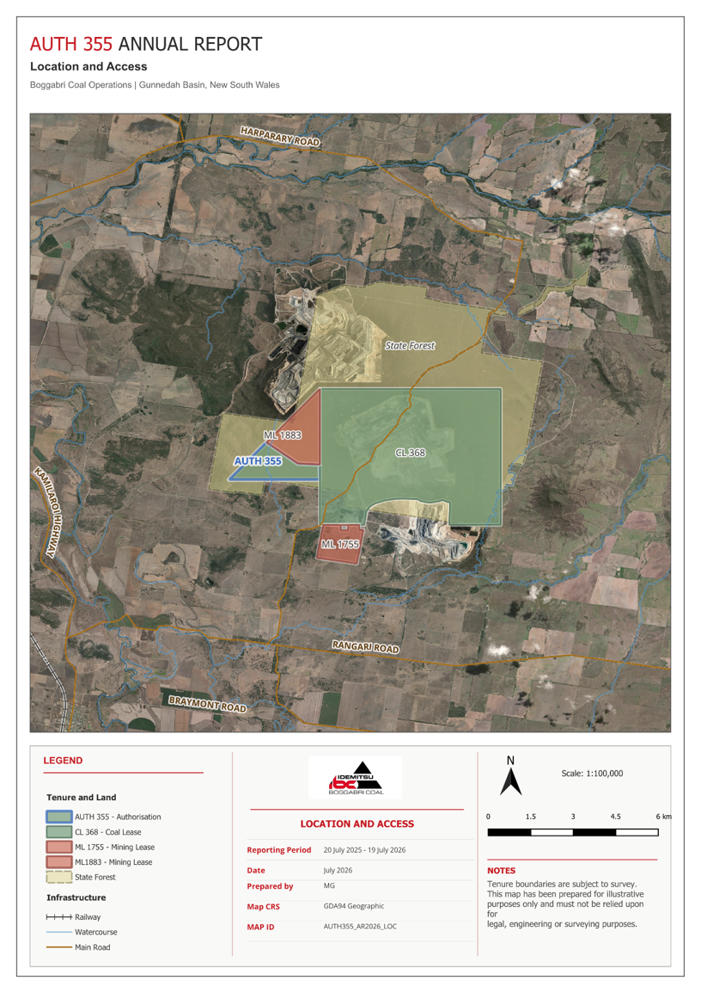
Figure 1-2: Location and access for Boggabri coal tenures

Community consultation undertaken in reporting period

Details of consultation
BCM operates a Community Consultative Committee (CCC) that meets on a quarterly basis. The purpose of this committee is to inform the community, via committee members, of all aspects of BCM’s activities, including exploration activities in A355.
BCM also informs its Registered Aboriginal Parties and other indigenous stakeholders via the Aboriginal Stakeholder Consultative Forum (ASCF) meetings held throughout the year.

Table 1: Dates and Times of Stakeholder and Consultation Activities
Consultation activity | Targeted stakeholders | Meeting dates | Mandatory or non-mandatory
Community Consultative Committee (CCC) Meeting | Members of the CCC (includes community representatives and Narrabri Shire Council) | 4th Sept 2025, 30th Oct 2025, 19th Feb 2026, 26th May 2026 | Mandatory
Aboriginal Stakeholder Consultative Forum (ASCF) | Registered Aboriginal Party (RAPs) and members of the Aboriginal community | 15th Jan 2026, 12th March 2026, 9th July 2026 | Mandatory

Respond to correspondence/submissions
In accordance with the Code of Practice, BCM responded to correspondence/submissions in a timely manner as correspondence/submissions were received.

Project email address and 1800 number
BCM managed the BCM project email address and phone number during the reporting period. The email address and phone number were monitored during normal business hours Monday to Friday, with emails and phone calls responded to in a timely manner as they were received.

Project updates on the Idemitsu Australia Resources website
The BCM Project webpage was monitored and updated as appropriate.

Dates and times
Due to the exploration areas being located solely within CL368 there has been no meeting for agreements or access with landholders, hence no dates and times section.

Objectives of community consultation events
Community consultation for the 2025/2026 exploration program was undertaken in accordance with the Code of Practice to ensure:
- open and honest dialogue that facilitates a sound working relationship between BCOP, landholders, and community with all participants cooperating in good faith;
- appropriate and adequate notification of the community and provision of information regarding exploration activities and future plans;
- mitigation and management of potential risks associated with conflict with community and other stakeholders;
- regular monitoring and review of the community consultation process and delivery;
- the local community and stakeholders can provide feedback and identify potential issues;
- provision of feedback back to participants on the results of their contribution; and
- identification of community investment opportunities that provide shared value for the community and BCM.

Issues and topics raised in discussion
Stakeholders are encouraged to raise questions and highlight issues or concerns during the meetings. Those issues or questions are that can be addressed during the meeting are answered or follow up undertaken and reported during the next meeting.

Table 2: Topics and issues raised in discussion
Community stakeholder | Overview | Date | Key points of discussion regarding exploration | Questions & Issues Raised
CCC | A project update is presented at each CCC meeting which includes the latest details on exploration (completed and planned holes) | 04/09/  2025 | - Deepening pit (Mod 8), tree clearing, Mod 10 | - No issues were raised
CCC |  | 30/10/2025 | Dam construction, exploration program update, rehabilitation and Mod 10 | No issues were raised
CCC |  | 19/02/2026 | - A355 Forestry agreement, Mod 10 | - No issues were raised
CCC |  | 14/05/2026 | - Exploration program and Mod 10 updates | - No issues were raised
ASCF |  | 15/01/2026 | - Grinding groove update (not located on A355) | - No issues were raised related to A355
ASCF |  | 12/03/2026 | - BC54 cultural site update (not located on A355) | - No issues were raised related to A355
ASCF |  | 09/07/2026 | - Environmental monitoring data, Forestry agreement, tree clearing | - No issues were raised related to A355

Government agency consultation undertaken in reporting period

Details of consultation
Consultation has been undertaken in the past 12 months on:
- Modifications 8 and 10.
- Forestry agreement
- Biodiversity offsets
- Approval commitments with Narrabri Shire Council

How feedback was collected
Feedback was collected during meetings with stakeholders and by providing stakeholder feedback mechanisms in the form of a dedicated project email address and project phone number. Feedback was documented using Consultation Manager, a stakeholder and consultation database.

Responses to any issues raised
No issues or complaints have been raised with BCM in relation to exploration activities in A355 during the reporting period.

Summary and nature of complaints received
No issues or complaints have been raised with BCM in relation to exploration activities in A355 during the reporting period.

Activity alterations in response to issues raised
No alteration to the activity was made as no issues or complaints were raised with BCM in relation to exploration activities in A355 in the reporting period.

Outcomes of the consultation
The primary outcome of the consultation conducted during this reporting period was a greater understanding of the project, and the mining and planning process. This contributed to fostering a positive relationship between BCM and Boggabri Exploration Project stakeholders by demonstrating a commitment to project transparency and largely meeting stakeholder expectations of involvement in consultation by BCM.
The consultation conducted during the reporting period also contributed to the following outcomes:
- a consistent provision of information across a range of stakeholders;
- a continued social license to operate.

Assessment of how well objectives were met
Table 4: Assessment of how well objectives were met
Objective | Contributions to meeting objective | Assessment of how well objectives were met (met, partially met, not met)
Open and honest dialogue that facilitates a sound working relationship between Boggabri Coal and the community. | - Regular meetings held with established community representative groups.  - Community feedback mechanisms were made available (i.e. project email and project phone number) to allow community members to raise any questions or concerns about the exploration program. | Objective met
Regular monitoring and review of the community consultation process and delivery | - Regular community consultation meetings were held internally to review and monitor the progress of community consultation. | Objective met
The local community and stakeholders can provide feedback and identify potential issues | - Community feedback mechanisms were made available (i.e. project email and project phone number) to allow community members to raise any questions or concerns about the exploration program.  - Community feedback mechanisms will remain available to stakeholders throughout the duration of the exploration program. | Objective met

Summary of amendments to the Communication Consultation Strategy or activity
No amendments to the EMS (includes the Community Consultation Management Strategy) were made.

Commitments for ongoing consultation
BCM will continue to consult with stakeholders through established communication forums. This includes:
- Regular meetings with key stakeholders through the CCC, ASCF and individuals as may be required,
- Respond to correspondence/submissions,
- Provide updates on the IA website, and
- Project email address and 1800 number.
Further details on the commitments to ongoing consultation activities are outlined in the sections below.

Regular Meetings with key stakeholders
In accordance with the Code of Practice, mandatory meetings/interviews will be held with key individuals and group representatives (either face to face, via teleconference, or over the phone) as requested.
Regular meetings with key stakeholders will continue to be conducted through CCC that meets on a quarterly basis, as well as continuing Aboriginal Stakeholder Consultative Forum (ASCF) meetings throughout the year to inform Registered Aboriginal Parties and other indigenous stakeholders.

Respond to correspondence/submissions
In accordance with the Code of Practice, BCM will continue to respond to correspondence/submissions in a timely manner as correspondence/submissions are received.

Project updates on the IA website
In addition to their mandatory requirements, BCM will provide up-to-date information about the Boggabri Coal Exploration Project on the BCM website as required. The company newsletter and FAQs will also be made available on the project website.

Project email address and 1800 number
In addition to their mandatory requirements, BCM will manage the BCM project email address and phone number. The email address and phone number will be monitored during normal business hours Monday to Friday, with emails and phone calls responded to in a timely manner as they are received.

